# EXERCISES

## Create HTML/CSS plus responsive for the following website

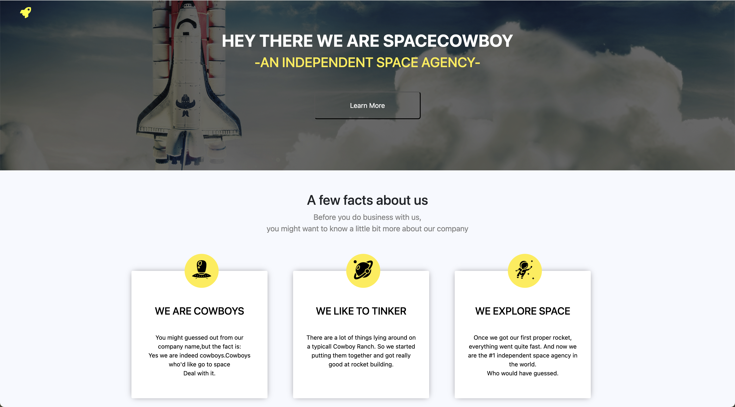

Figure 1: Part 1

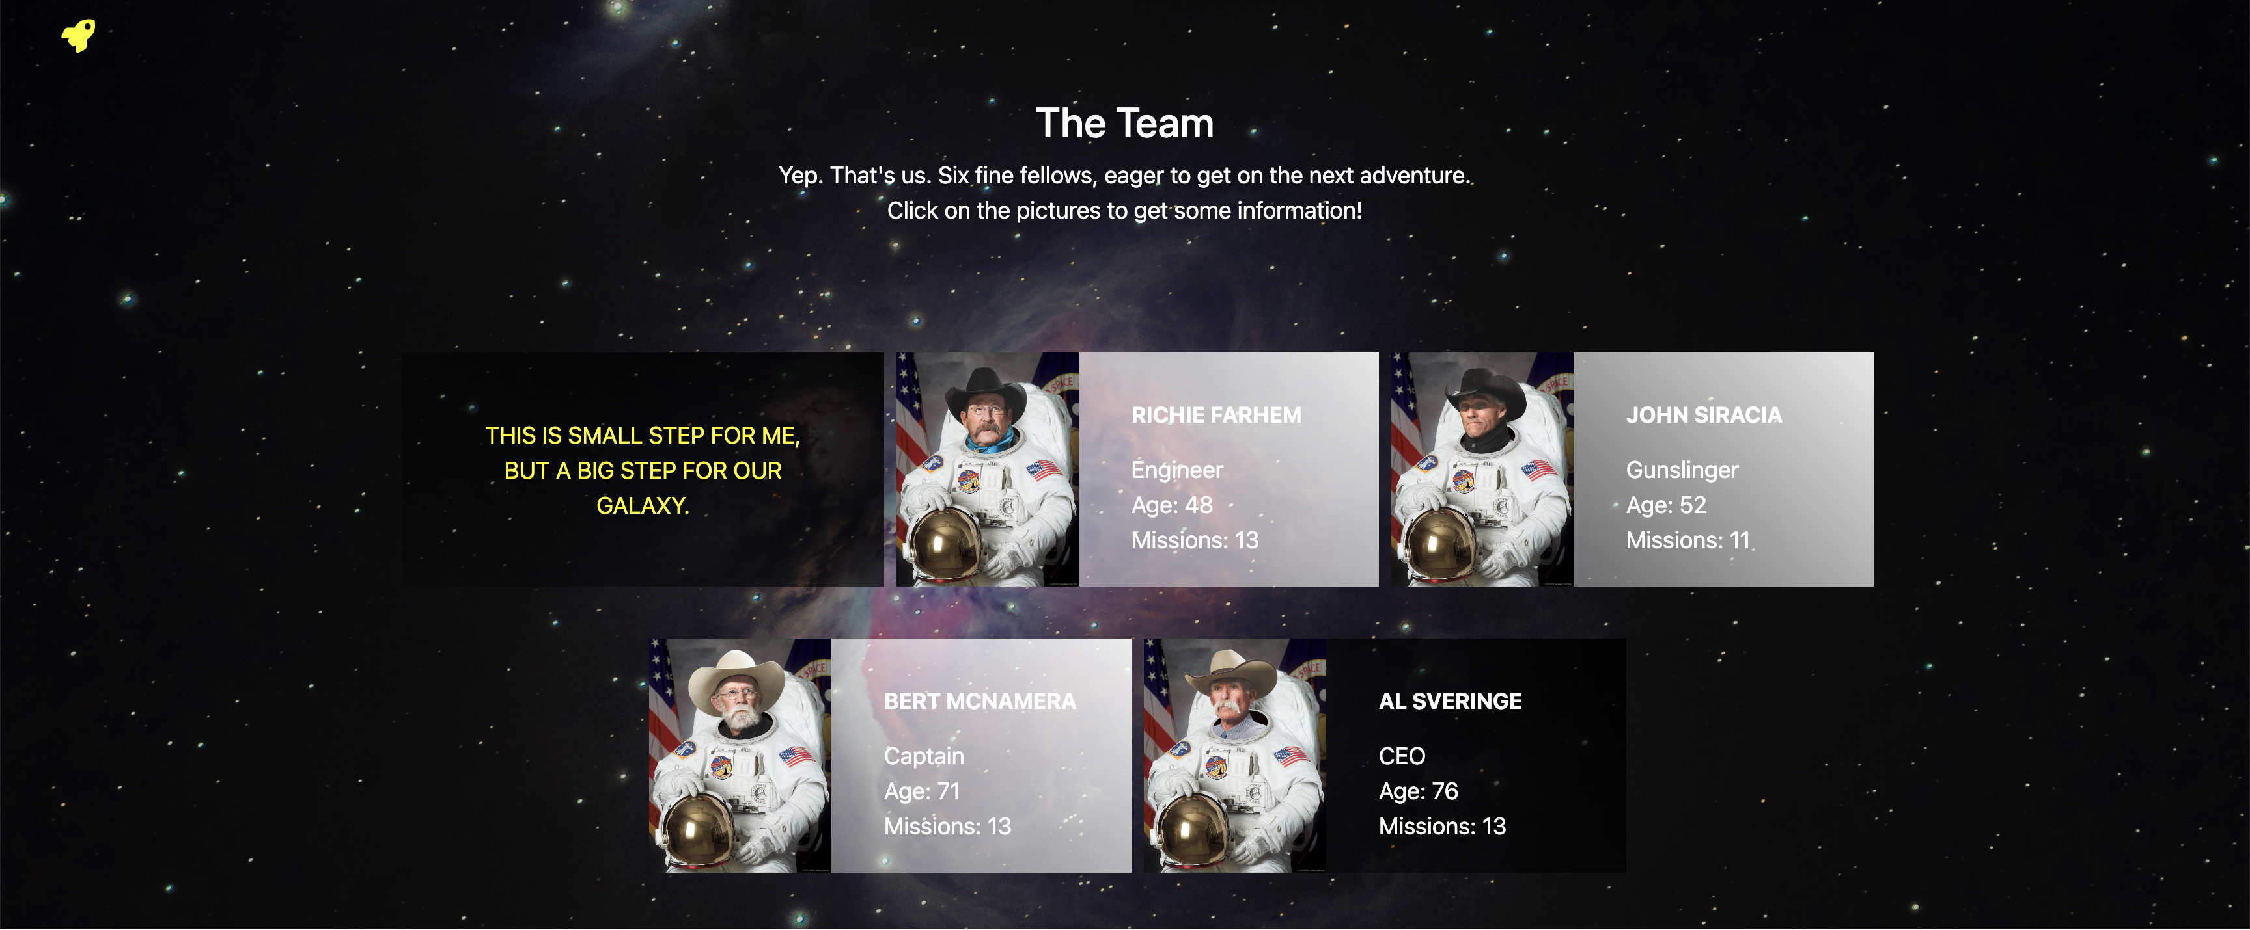

Figure 2: Part 2



Figure 3: Part 3

Images and necessary materials are included in folder Materials

## Guidelines

* Generic yellow color code: #f4ec7a
* Max width of body is Max-width: 960px
* For the background image cover at the top of Figure 1. Add this advanced line

background: linear-gradient(rgba(0, 0, 0, 0.6), rgba(0, 0, 0, 0.6)), url('images/header_background.png');

🡺 Replace your image above with your desired directory.

* For button at the top: Use:

background-color: transparent

to make transparent background color

For figure 1, to make box has shadow, using this line

Box-shadow: 0px 0px 15px -4px rgba(112, 108, 112, 1)

## Transform your website to responsive

An idea for responsive like this in mobile phone



